**Tutorial 41: Vue Router – Programmatic Navigation**

Vue router uses the Web history API and that means we can go forward and backwards using the buttons on the browser through the history of our journey in the website.

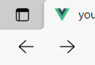

In this tutorial we are going to explore how we can access the functionality programmatically in the Vue application to send the user back a page or forward a page through the history. We will also be exploring how we can programmatically redirect them to another route by pushing a new item on to the history.

Make sure **Tutorial 40** is complete to be able to move on to this tutorial or clone the [vue3-firebase-course](https://github.com/younggrasshopperza/vue3-firebase-course) repository and go to branch called **Tutorial-40** and navigate to the young-grasshopper-jobs folder.

**Step 1:** In the App.vue file, under the div with an id of nav, create 3 buttons, the first button will redirect the user, the second button will be to go back a page and the third button will be to go forward a page through the history.

Look at the example below (**Between line 7 and 9**):

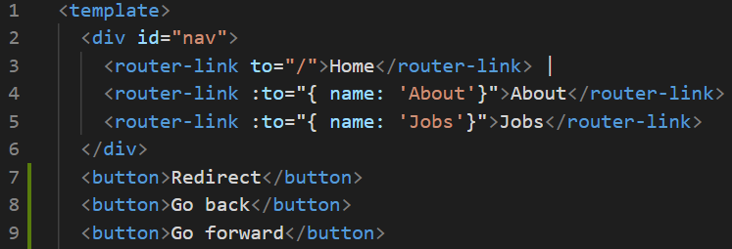

Paste the following css into the style tag:

button {

  margin: 0 10px;

  padding: 10px;

  border: none;

  border-radius: 4px;

  cursor: pointer;

}

**Output:**

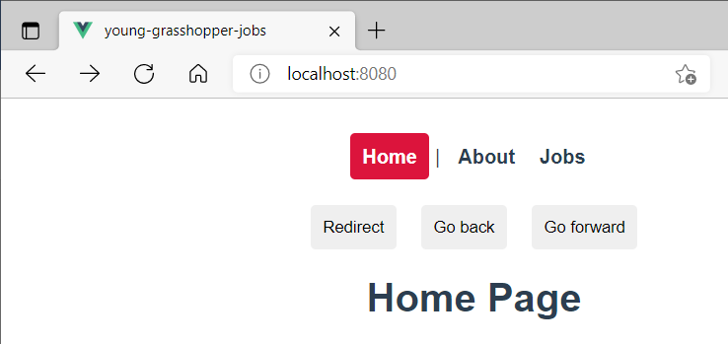

**Step 2:** In the App.vue file, attach click events to each of the buttons created. The first method will be called redirect, the second method will be back and the third method will be called forward.

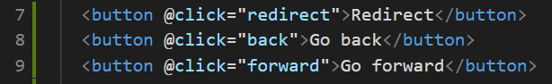

Create the script tag that export default, create the methods property with the three methods mentioned above.

Look at the example below (**Between line 13 and 21**):

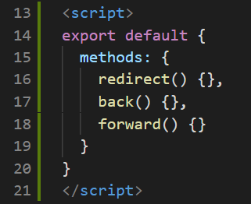

**Step 3:** In the App.vue file, we want to access the router functionality to go back when we type this to reference the component instance along with the dollar sign, router

**this.$router**

Before we used **this.$route** to get the route parameter, do not get confused. This is used to get information about the current routes.

We use **this.$router** when we want to do something like move between pages. We can call the method go, **this.$router.go()** and provide a positive or negative number as an argument to go.

**this.$router.go(-1)**

Providing a negative number means going back a page, example -1 means go back by 1 page, -2 means go back by 2 pages.

Look at the example below (**Between line 17 and 19**):

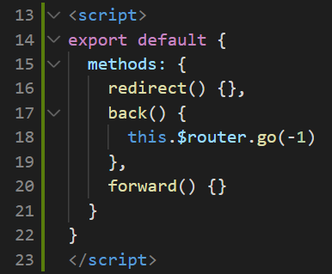

Navigate to the Home page, then navigate to the About page, then navigate to the Jobs page. Then click the back button.

**Output:**

Starting from Jobs page. Click “Go Back”.

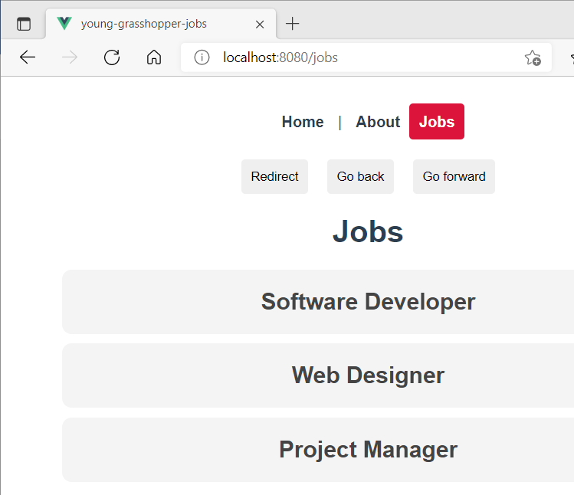

Landed on the About page. Click “Go Back”.

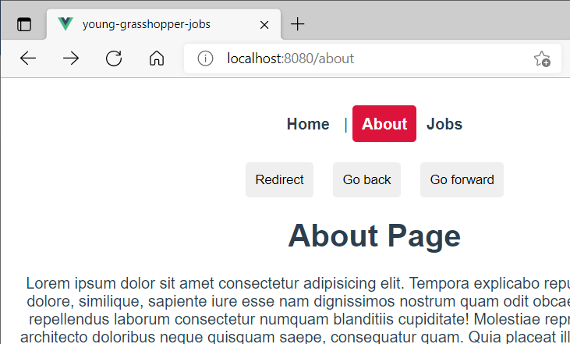

Landed on the Home page.

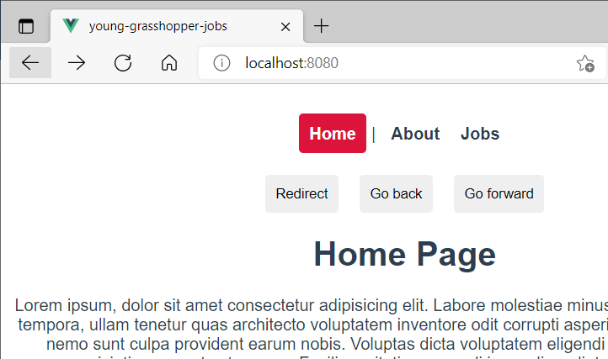

**Step 4:** In the App.vue file, we want to access the router functionality to go forward

We can call the method go, **this.$router.go(1)**

Providing a positive number means going forward a page, example - means go forward by 1 page, 2 means go forward by 2 pages.

Look at the example below (**Between line 20 and 22**):

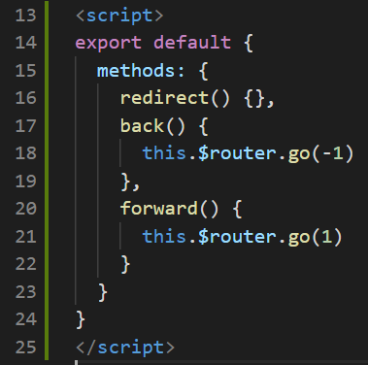

**Output:**

Assuming you did not refresh when you tested and went back let’s click go forward

Starting from Home page, click “Go Forward”.



Landed on the About page. Click “Go Forward”.



Landed on the Jobs page.



**Step 5:** In the App.vue file, in order for us to redirect a user we push an extra route to the history. Inside the redirect method, type the following **this.$router.push({ name: ‘Home’ })**

This allows us to navigate to the home page when we click the redirect button.

Look at the example below (**Between line 16 and 18**):

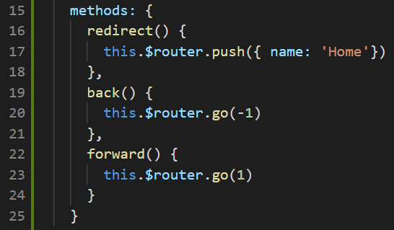

On the About page click the button “Redirect”.

**Output:**

From the About page:



To the Home page:



**You can view the code snippets from the** [**vue3-firebase-course**](https://github.com/younggrasshopperza/vue3-firebase-course) **repository under the Tutorial-41 branch**.